**Driver-Assistant Software Instruction**

Jingwen Mo

Yiming Chen

Supervised by Prof. Quoc-Viet Dang

**July 23th, 2018**

# Introduction

## Purpose

The Data-Graph Software is a PC based software developed to draw the graph which depicts different sensors for the racing car and show the GPS information. This instruction is for the software users and software tester.

## Background

Racing car is one of the fiercest activities. It requires people to have access to different sensors in the car in order to evaluate the performance of the driver and train the driver by the feedback from the sensors. Our software is meant to help coach to transfer the data of different sensors to intuitive graphs easily.

# Software overview

## Overview

The whole structure of our software could be shown as following flow chart:

1. Load CSV Files

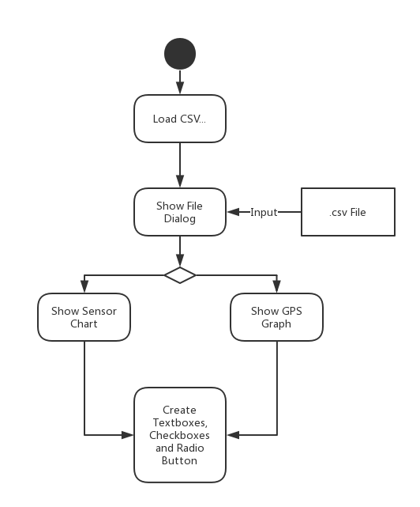

2. Show Specific Value of Points

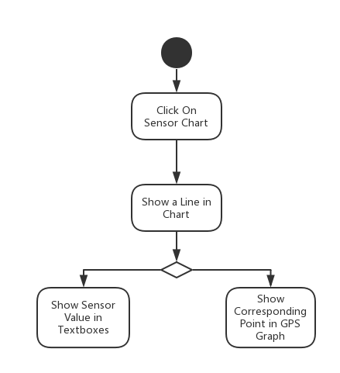

3. Make the Chart Flow

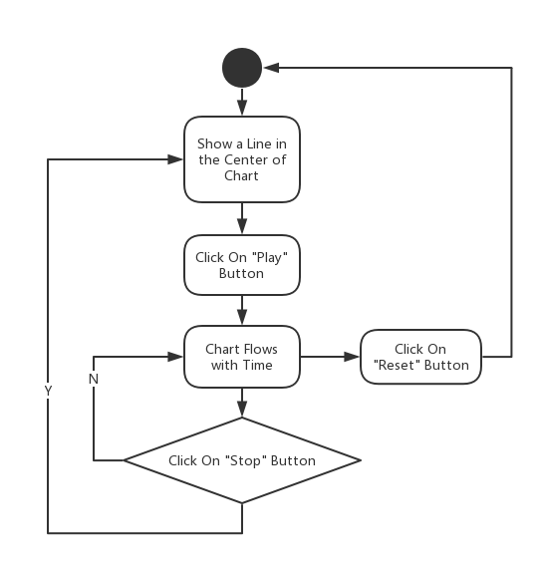

4. Choose Different Type of Y Axis

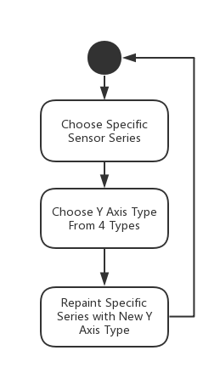

5. Customize X axis and Y axis

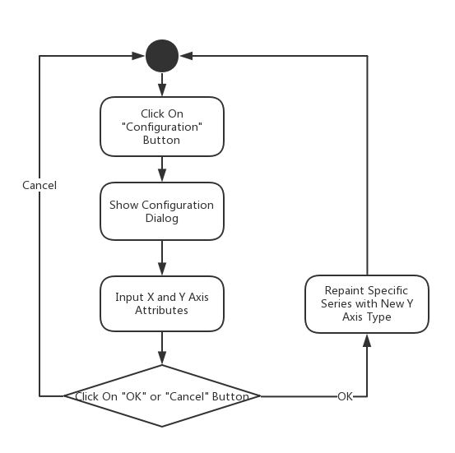

6. Save and Load Setting Log Files

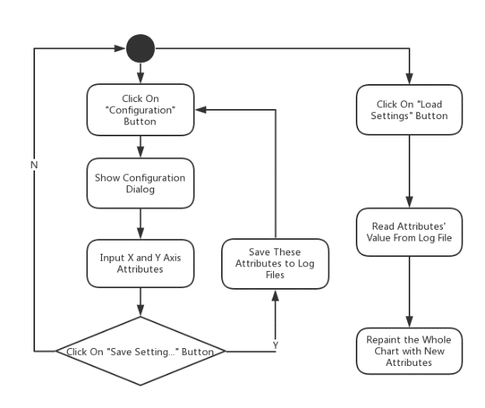

7. Show or Hide Specific Series

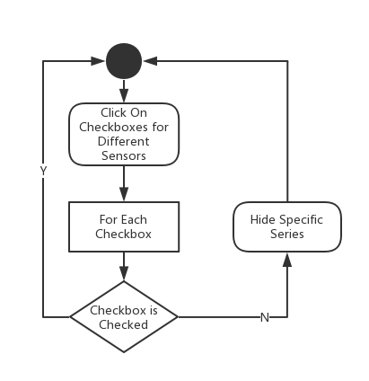

8. Show Colored GPS Graph Changed by Speed or Acceleration

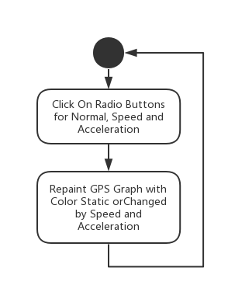

9. Drag Mouse on the Chart

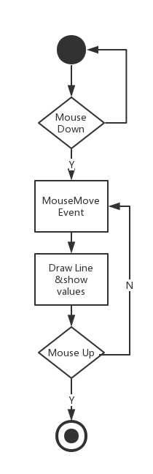

## Details

1. Load CSV Files - Click on “Load CSV…” Button

Call function of fileLoadingButton_Click and pop up a file dialog for users to choose their CSV file. After users choose their files and the columns for latitude and longitude, the software could draw graphs for different series of sensors and the GPS graph for the route of driving. Also, the software would dynamic create textboxes, checkboxes and radio buttons for different sensors.

Related Functions:

void fileLoadingButton_Click(object sender, EventArgs e)

DataTable OpenCSV(string filePath)

2. Show Specific Value of Points - Click on the chart

Users could click on the graph and show a vertical line at where the mouse click. Then the textboxes below would show the values of different sensors. Meanwhile, there would be a black point in the GPS graph to show the same place as you click on the chart.

Related Functions:

void sensorChart_MouseClick(object sender, MouseEventArgs e)

int findLeftNear(double value, double[] array, int length)

3. Make the Chart Flow - Click on “Play”, “Stop” and “Reset” button

Users could click on “Play” button and call the function of buttonPlay_Click. This function enables chartTimer so that it could repeatedly execute the function of chartTimer_Tick at intervals. In the meantime, the textboxes below would show the values of sensors as the chart flowing. When users click on “Stop” button, the chart would stop flowing. After “Play” button is re-clicked, the chart would begin to flow from where it stops. The “Reset” button would let users to reset the chart to the original state.

Related Functions:

void buttonPlay_Click(object sender, EventArgs e)

void buttonStop_Click(object sender, EventArgs e)

void resetButton_Click(object sender, EventArgs e)

void chartTimer_Tick(object sender, EventArgs e)

4. Choose Different Type of Y Axis - Click on “R1”, “R2”, “R3” or “R4” radio button

Users could change different series from one Y axis to the other one. The software provides 4 different Y axis. The change of axis could be change by radio buttons dynamically created by fileLoadingButton_Click function.

Related Functions:

void change(int no, ChartArea caR)

void rb1_Click(object sender, EventArgs e)

void rb2_Click(object sender, EventArgs e)

void rb3_Click(object sender, EventArgs e)

void rb4_Click(object sender, EventArgs e)

5. Customize X axis and Y axis - Click on “Configuration” button

Users could click on “Configuration” button to pop out a dialog for X axis and Y axis customization. Users could change the range of X axis range, scale and interval and Y axis range and type.

Related Functions and Forms:

public partial class RangeForm : Form

void YRangeForm_Load(object sender, EventArgs e)

void confirmButton_Click(object sender, EventArgs e)

void ConfigureButton_Click(object sender, EventArgs e)

6. Save and Load Setting Log Files - Click on “Saving Setting…” and “Loading Settings” button

By clicking button of “Saving Setting…” in RangeForm, users could save log files with the X axis and Y axis configuration in specific form. Also, users could load log files created by them by clicking the button of “Loading Settings”.

Related Functions:

void settingSaveButton_Click(object sender, EventArgs e)

void settingButton_Click(object sender, EventArgs e)

7. Show or Hide Specific Series - Click different checkboxes in displayPanel

User could click on different checkboxes created dynamically by fileLoadingButton_Click function. By the way, there is an allSelectedCheckBox for the selection of all.

Related Functions:

void sensorCheckedListBox_ItemCheck(object sender, ItemCheckEventArgs e)

void allSelectedCheckBox_CheckedChanged(object sender, EventArgs e)

8. Show Colored GPS Graph Changed by Speed or Acceleration - Click different radio buttons in GPSGroupBox

Users could click on “radioButton_Normal” to show normal GPS graph, “radioButton_Speed” to show GPS graph changed by speed where green represents high speed and red represents low speed and “radioButton_Accelerate” to show GPS graph changed by acceleration.

Related Functions:

void radioButton_Normal_CheckedChanged(object sender, EventArgs e)

void radioButton_Speed_CheckedChanged(object sender, EventArgs e)

void radioButton_Accelerate_CheckedChanged(object sender, EventArgs e)

int colorRed(double x)

int colorGreen(double x)

9. Drag Mouse on the Chart - Just drag the cursor on the chart

Users can drag the red line randomly in the chart. The chart will listen on “MouseDown” event to trigger “MouseMove” event and “MouseUp” event to end “MouseMove” event.

Related Functions:

void sensorChart_MouseMove(object sender, MouseEventArgs e)

void sensorChart_MouseDown(object sender, MouseEventArgs e)

void sensorChart_MouseUp(object sender, MouseEventArgs e)

# Testing and Results

## Testing Environment

- Visual Studio 2013&2015

- Programming Language: C#

## Results

1. Load CSV Files

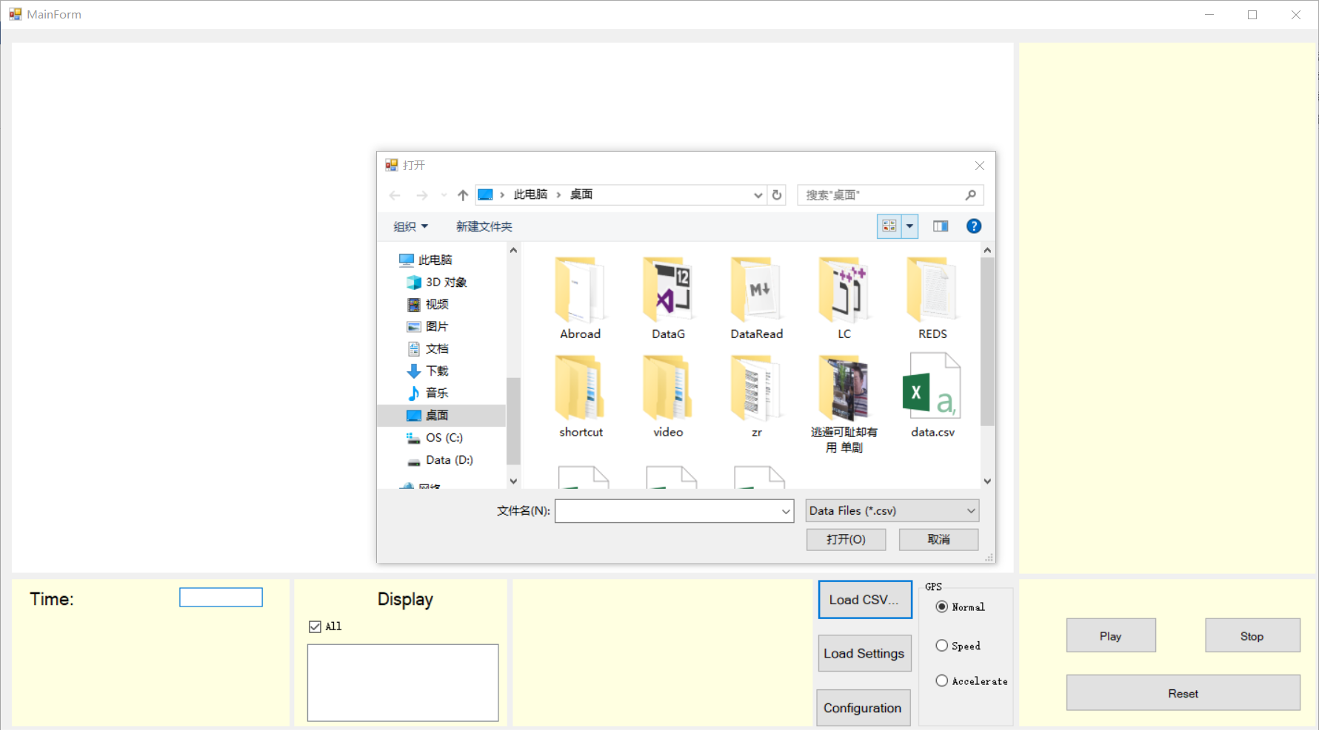

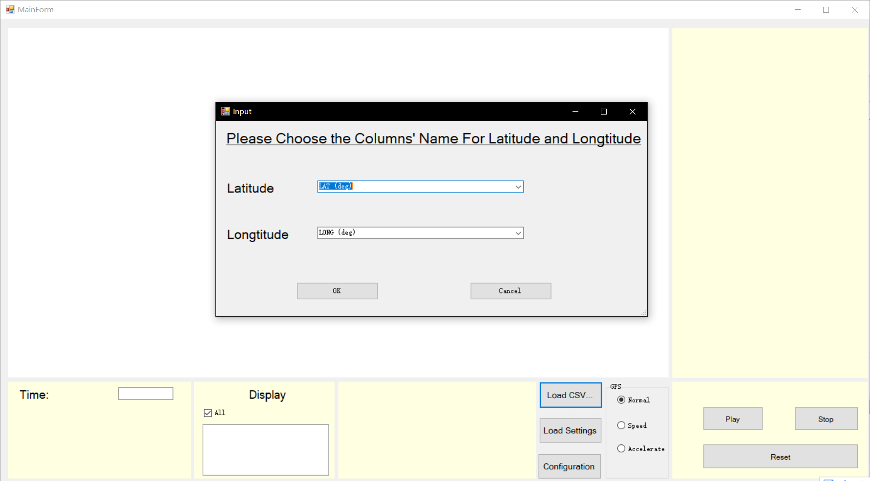

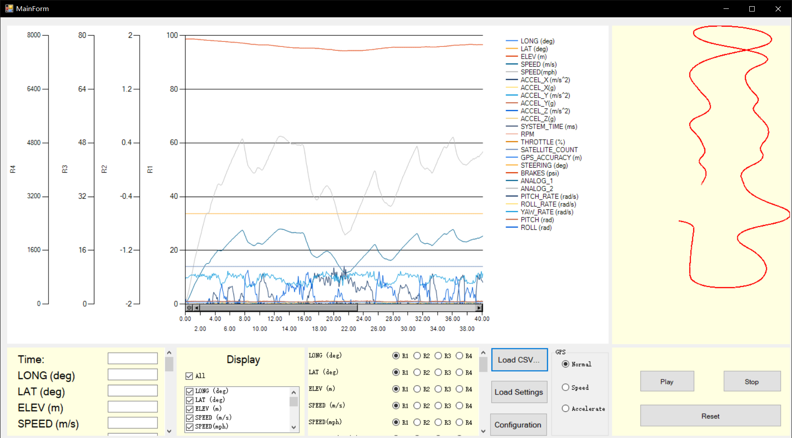

2. Show Specific Value of Points

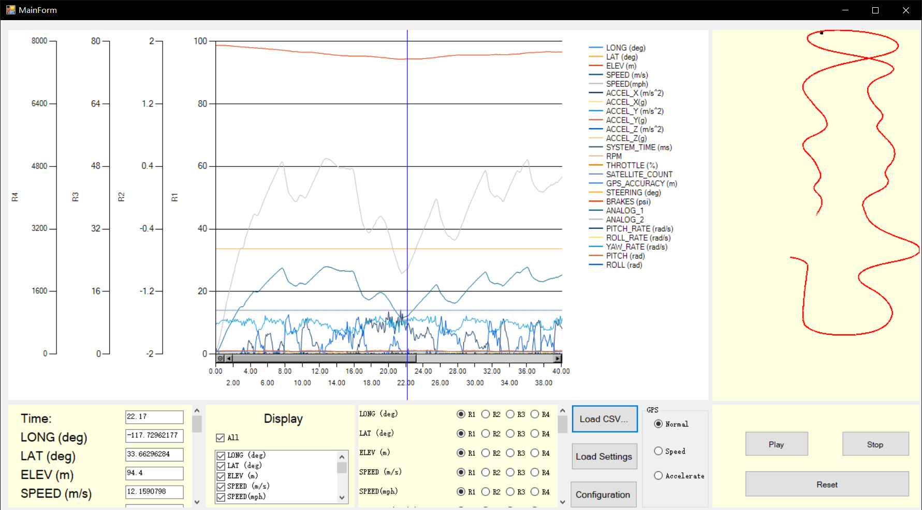

3. Make the Chart Flow

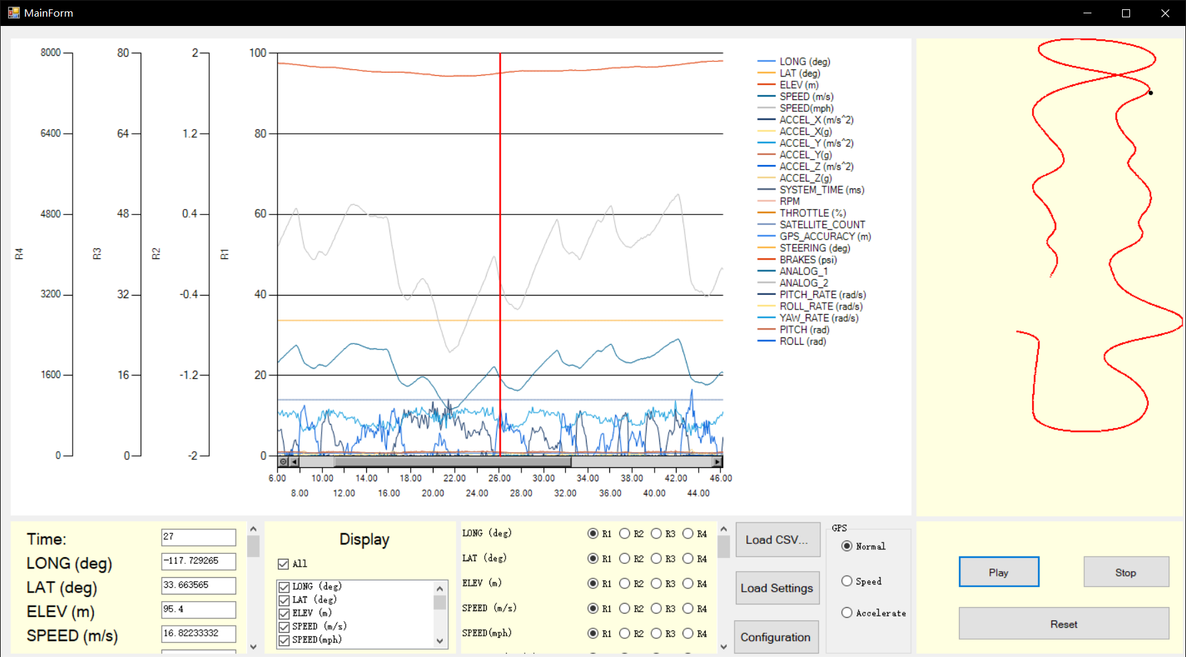

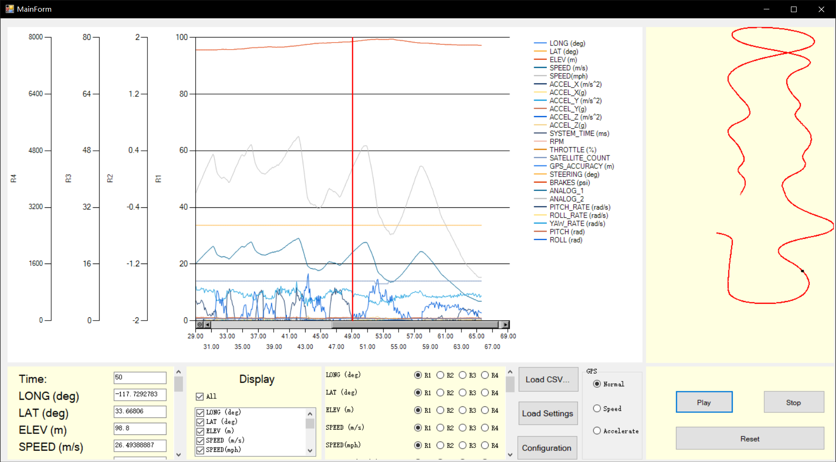

4. Choose Different Type of Y Axis

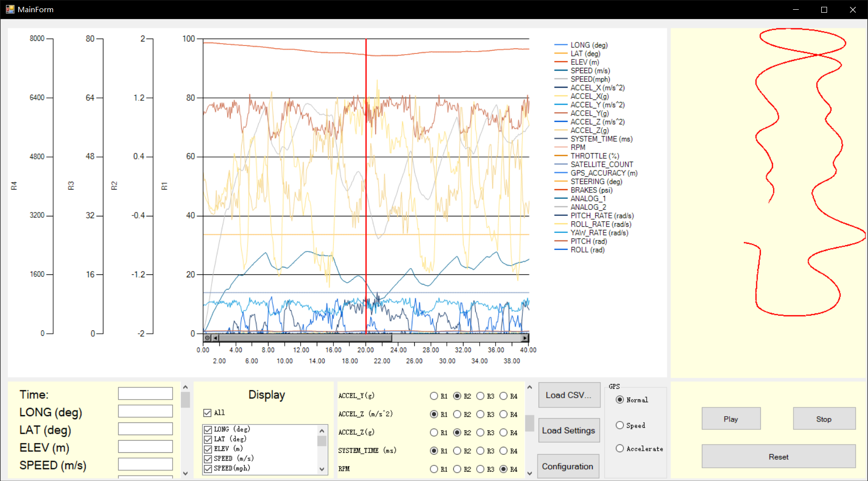

5. Customize X axis and Y axis

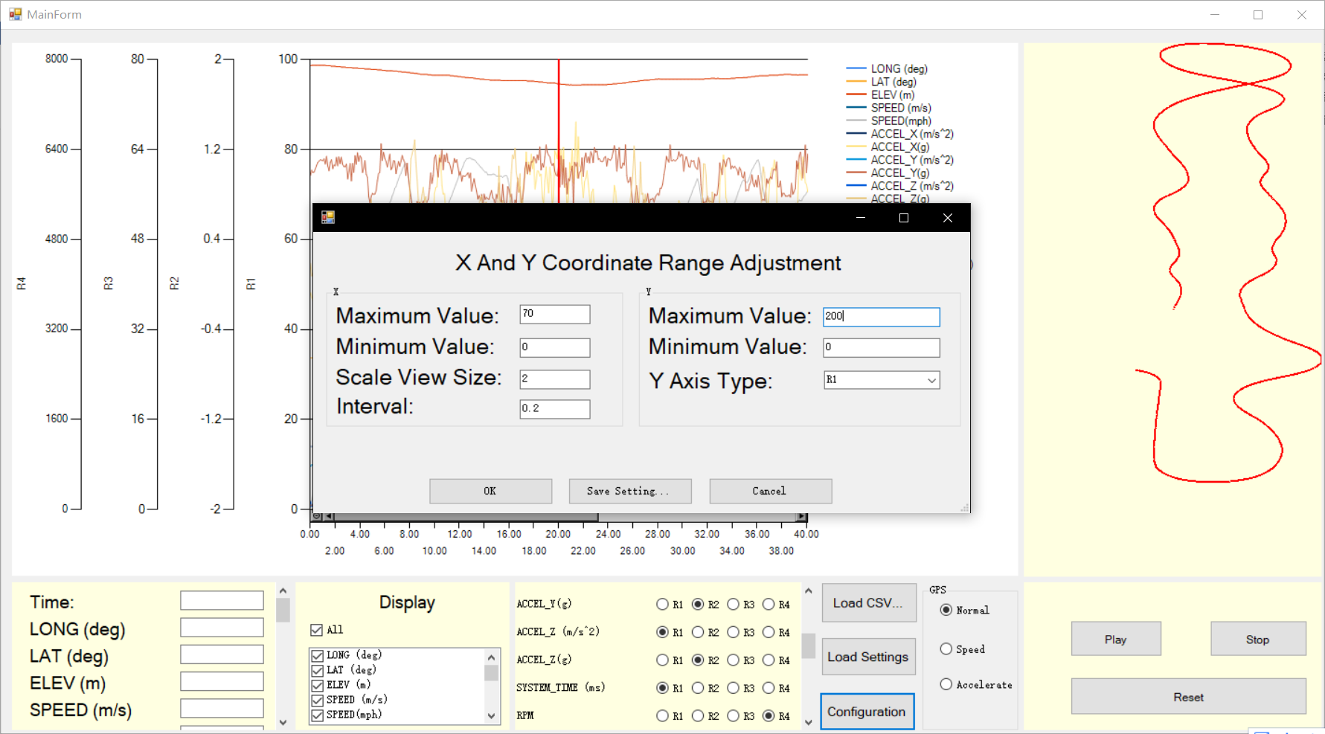

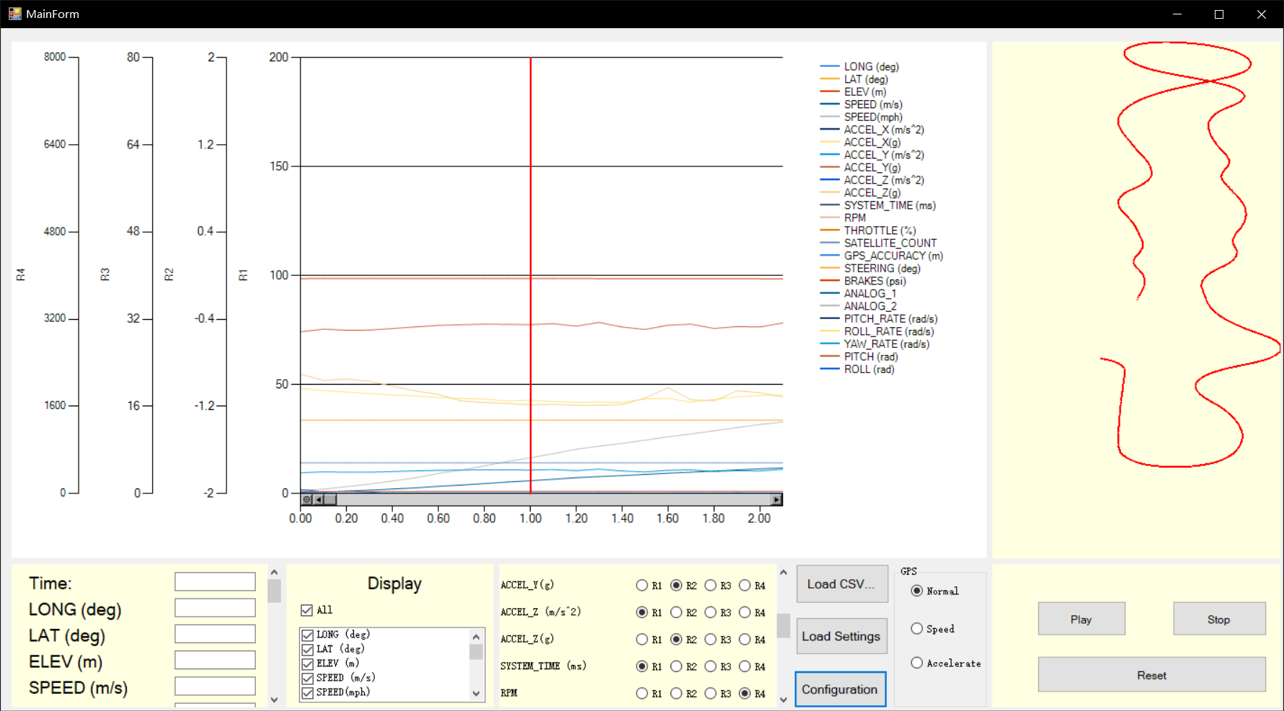

6. Save and Load Setting Log Files

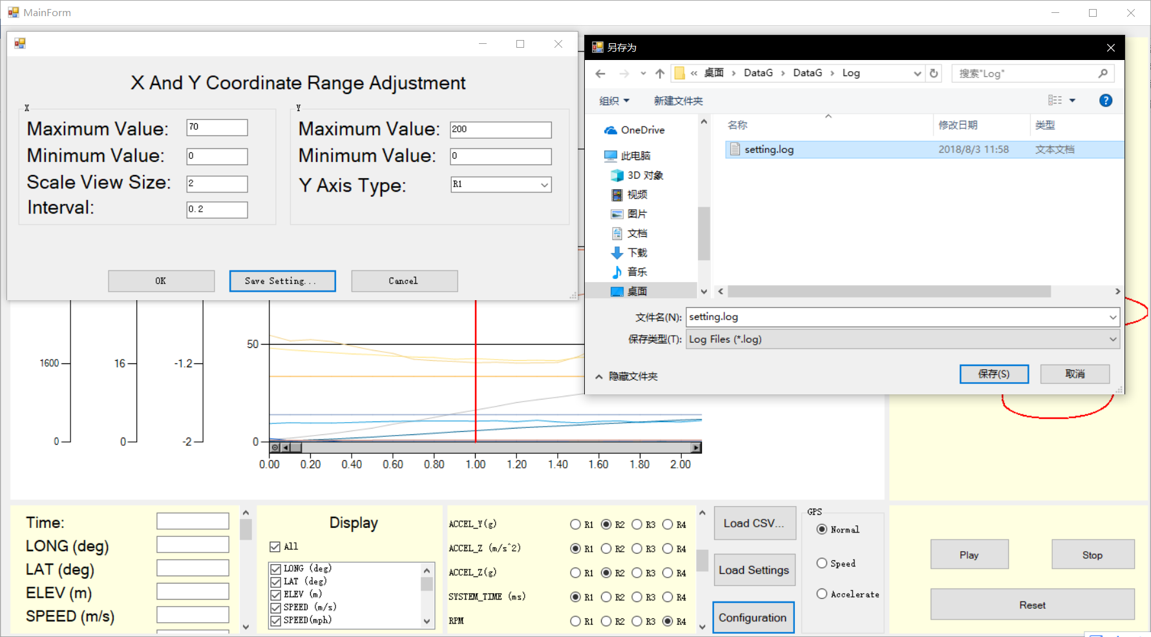

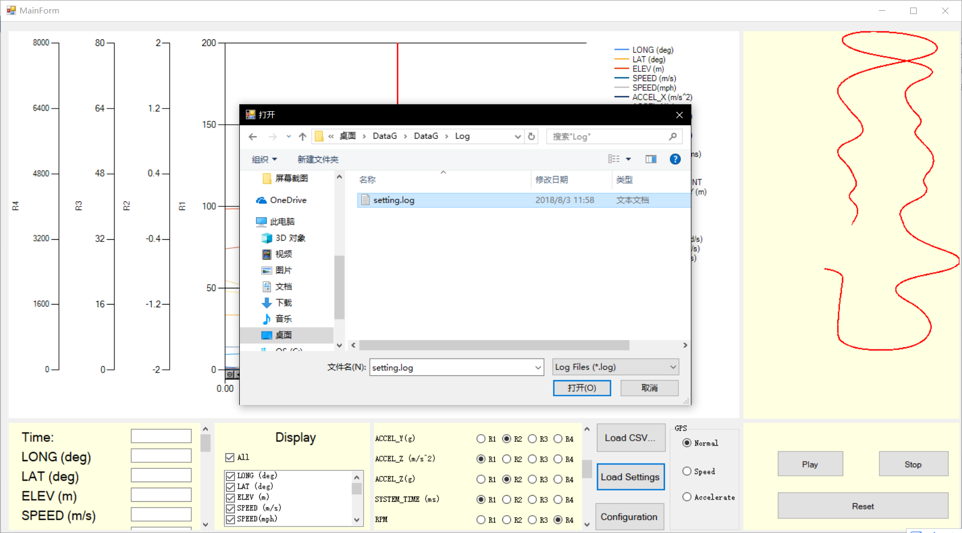

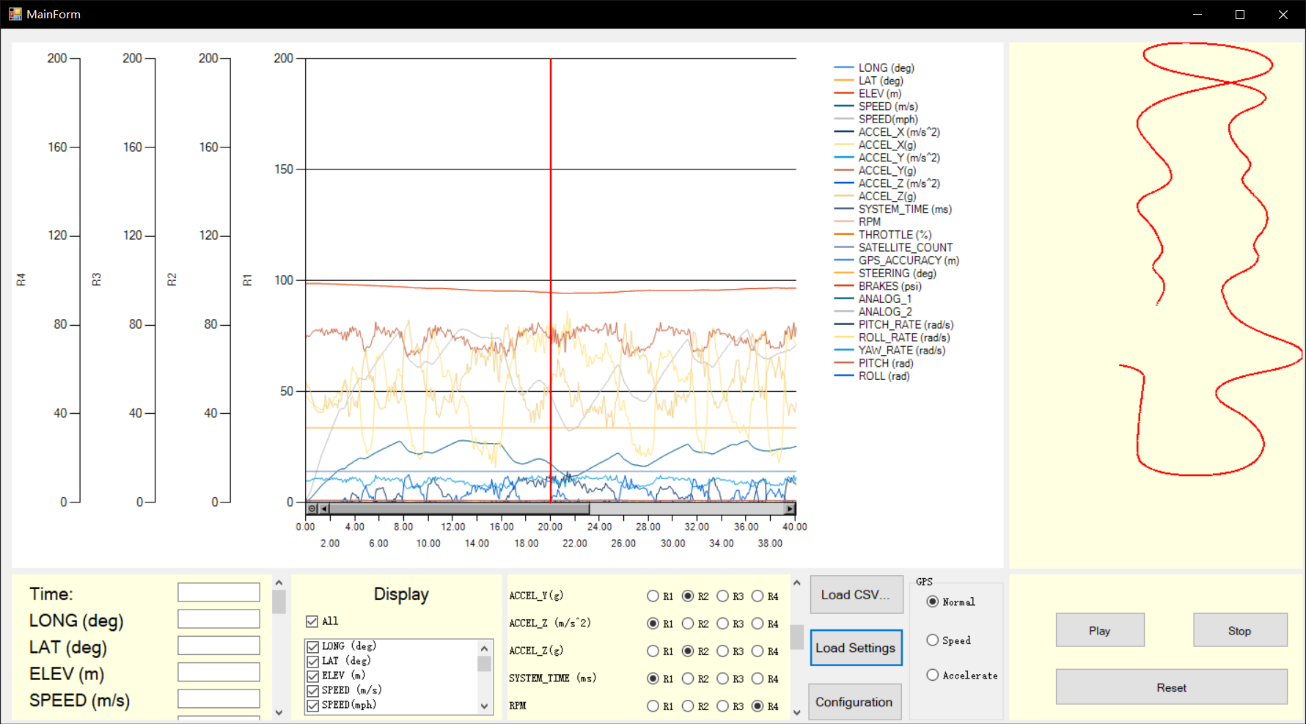

7. Show or Hide Specific Series

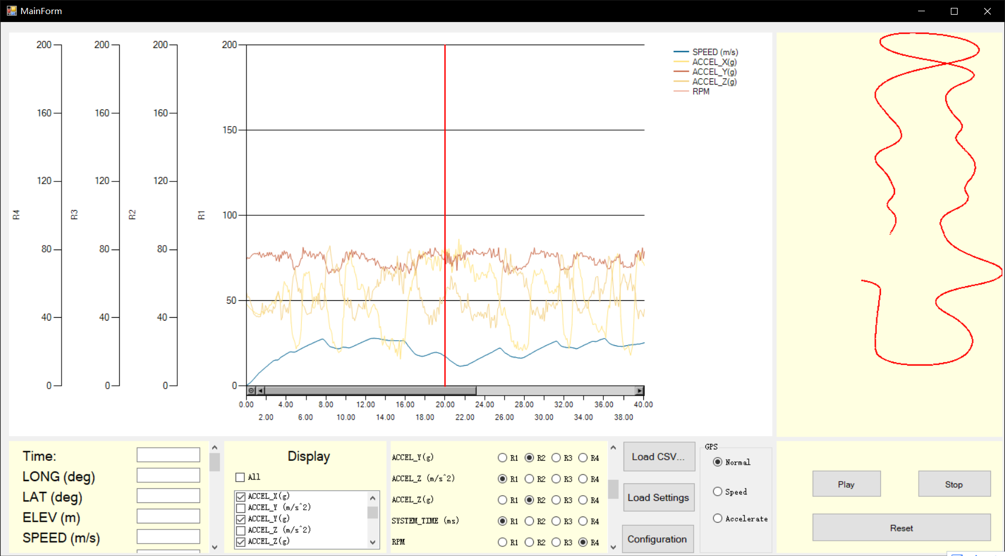

8. Show Colored GPS Graph Changed by Speed or Acceleration

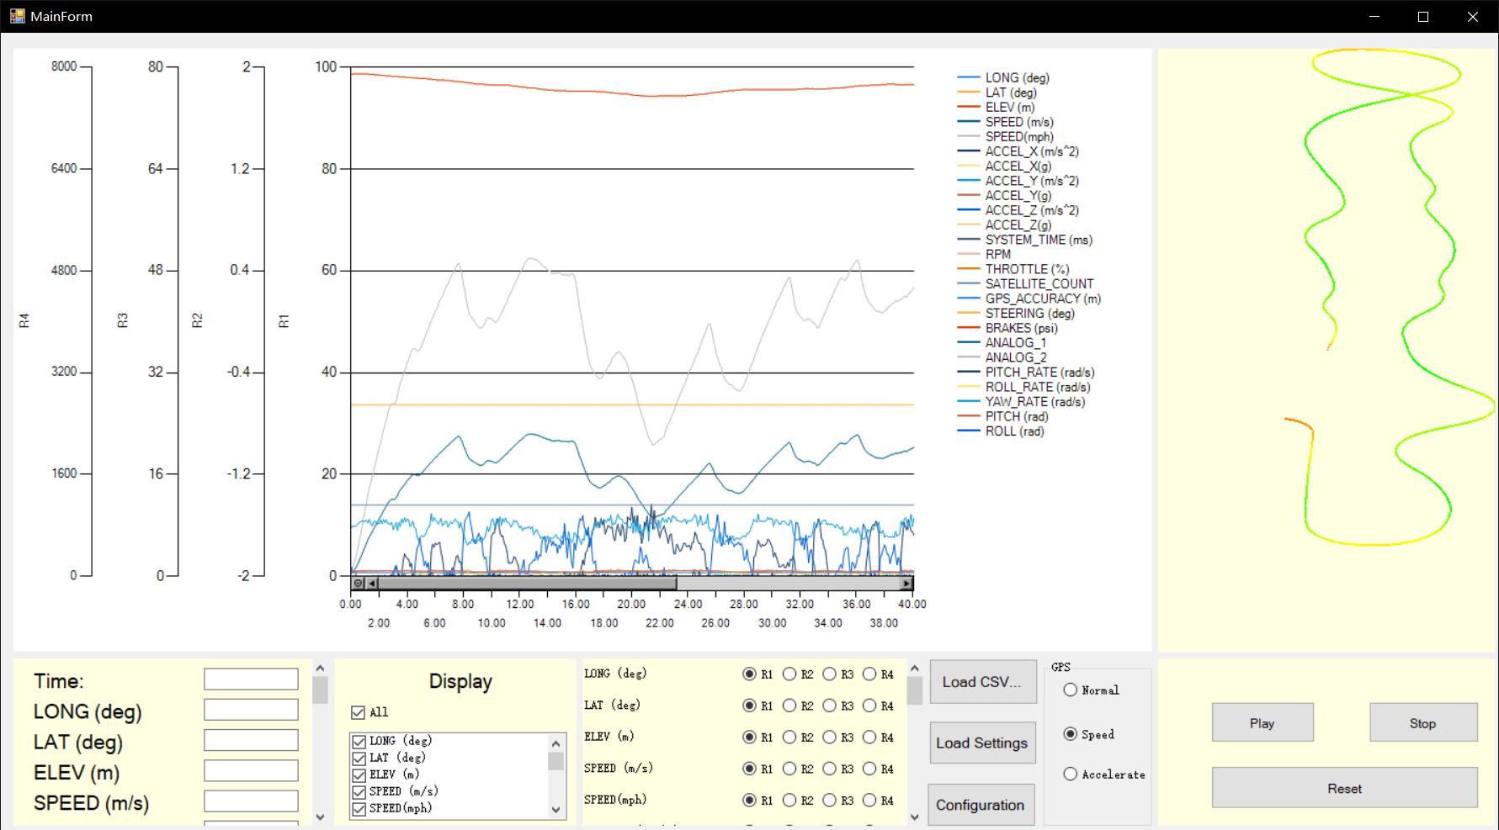

9. Drag Mouse on the Chart